Background:
For assignment two, we were tasked with inputting data from a text file that contained 300 scattered points that related to $\left\{\left(x_{i}, y_{i}, z_{i}\right)\right\}, i=1, 2, …, 300$. Once we have imported these points, the next task is to interpolate the data points using the "griddata" function from MATLAB and plot the resulting surface.

Method:
Our first step in building this code is to use the "load" function from MATLAB to access the data points from a test file titled "intpts." This file has the x, y, and z values stored as one entry, where an entry is a row in the file. So, our next step is to create three separate vectors from this file. We need to work efficiently with data since the other functions used later in the code need separate x, y, and z inputs.
Now that we have our three separate vectors, we need to find the maximum and minimum x and y. We need these values to set the upper and lower bounds for each value's function "meshgrid." The function "meshgrid" returns a 2-D grid of coordinates based on what is contained in the vectors of x and y. It should be noted here that the outputs of "meshgrid" will also be vectors. In this case, we built a grid using points between the maximum and minimum values for x and y, but with a spacing of 0.1, these points were labeled as xq and yq.
Since we have the new vectors of xq and yq, we can use the function "griddata" to start building the surface that will fit our given data points. In this case, the function "griddata" will interpolate this surface using the query points from xq and xq to produce a vector of interpolated values zq. So, for the function of "griddata," we will need x, y, z, xq, and yq to produce the zq. However, using the help feature in MATLAB, it can be shown that one can select a specific method of interpolation that "griddata" will use. In the case of the code we have built, the method selected was cubic since this produced a function with smoother curves that are more visually appealing.
However, we still have a bit of data cleaning that we need to complete. In the vector of zq, some inputs have a value of NaN, which means that they have no value. This is problematic because any values correlating these NaN points cannot be plotted. So, to correct this, create a variable called "in," which identifies any zq values equal to NaN. Next, we enter the line "zq(in)=0," which sets all zq values equal to 0. Now, every point has a value that can be plotted on the surface, and we can now create our plots. To create the plots, we will use "surf" to create the surface using xq, yq, and zq and the "plot3" using x, y, and z to create the scatterplot.

Conclusions:
Now that our code is finished, we can produce the plots from the imported data. We will start by building the surface that we will identify as "figure(1)," which means this is the first figure produced. Here, we will use "surf(xq, yq, zq)" to produce this plot. Next, we will have "view(75,15)" to make the plot's angle more appealing to the viewer. Then, we will use "colorbar" to produce a scale to represent what the color gradient means. Finally, we added a title and axis labels to complete the graph. The final result of this graph can be viewed below.
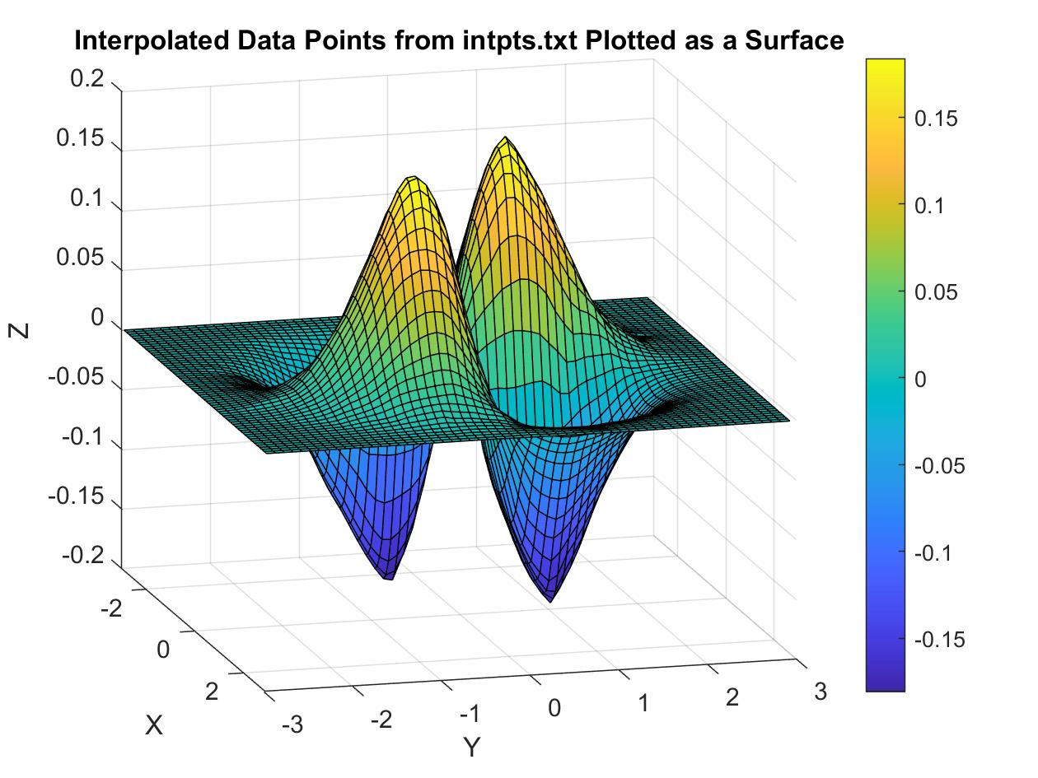
Now that we have the surface plot, which in code is called "figure(2)", we need to complete the scatterplot. However, this graph is more straightforward to produce. We will use "plot3(x, y, z)" to plot the vectors we created directly from the data import. Now, for this plot, a title was added and axis labels. However, the view for the scatterplot was set as the same as "figure(1)". So, the resulting graph of these points can be viewed below.
